*Marmara University*

***Faculty of Engineering***

***Computer Science Engineering Department***

***CSE4094 – Advanced Data Structure***

Search Engine Report;

Harun Büyüktepe 150115020

In this assignment, I implemented a mini search engine in python language. I used the trie structure to do this work, in order to use the easy implantation ability of trie data structure.

We have defined a class to build the trie structure, this class processes with trie nodes.

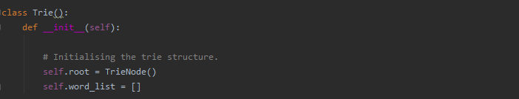

(Trie Class)

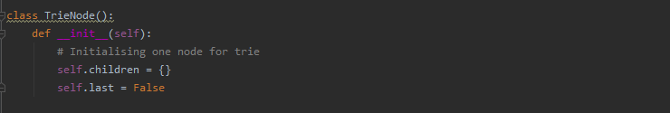

(Trie Node Class)

The Trie class performs basic trie operations. First of all, the insert function inserts our key into the tree accordingly, our eligibility condition is the absence of the key specified in the trie.

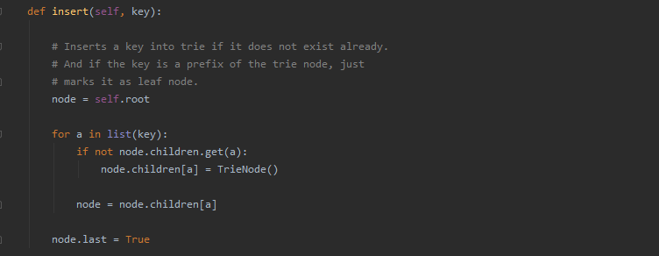

(Insert function)

Our next function is formTrie, runs the insert function for each word in the given word set. 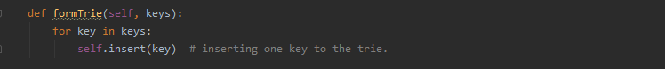

The search function is the function that checks whether the key is fully match in any trie node. Return true or false.

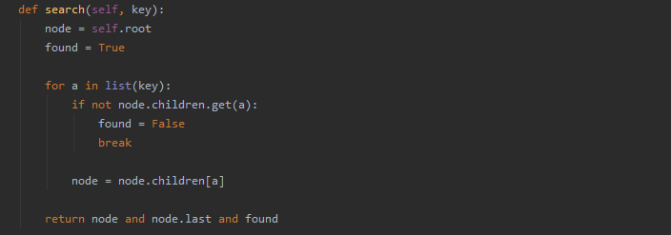

(Search function)

The mini engine function checks that the key given exists, returns zero when not available, then calls the getAll function to bring the same prefix words. It also provides the position of the given prefix with the get_position function.

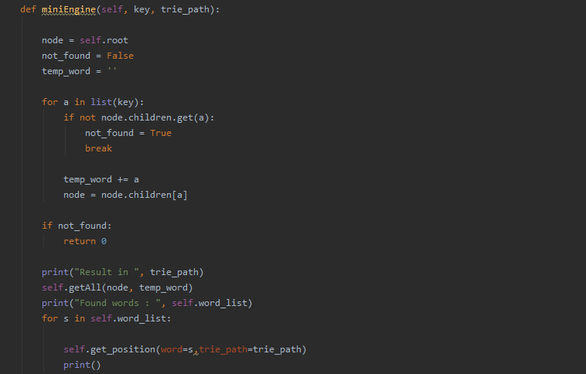

(miniEngine function)

GetAll recursively found words and append the word list, this word list used in mini search engine.

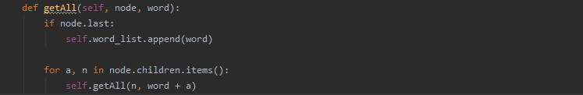

(miniEngine function)

Get position function get char index from text.

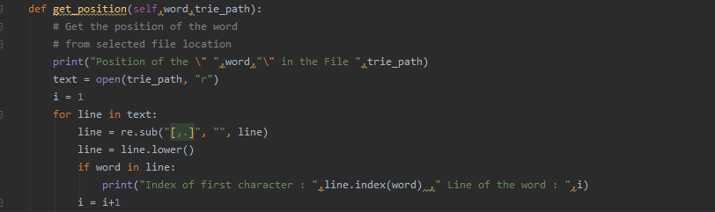

(get_position function)

And I have a main function, it call starter fonction with file path argument.



(main function)

Furthermore, at start of the python script, I use the global file_list and path information.



(main function)

The main operations were carried out in the starter function. A terminal screen menu is provided for the user to select the action to take. Regardless of the process it chooses, if the path information is empty, the user is prompted for path information. The transaction then takes place with sufficient information received from the user.

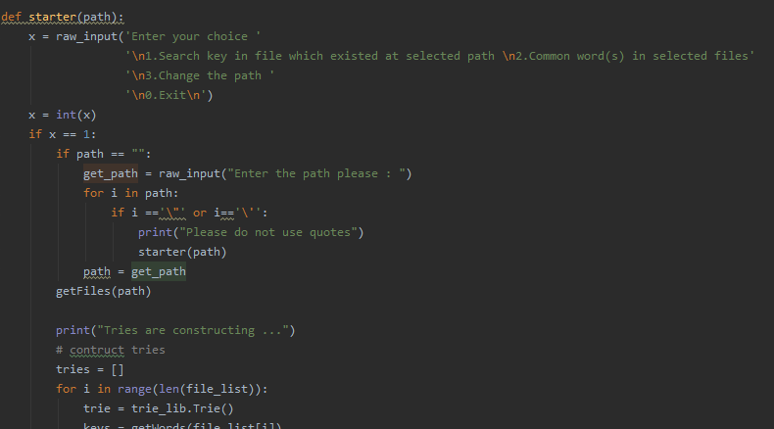

(Starter function)

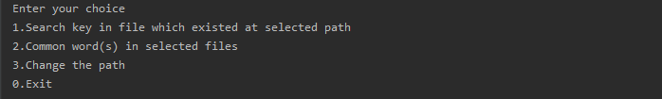

(Simple Menu)

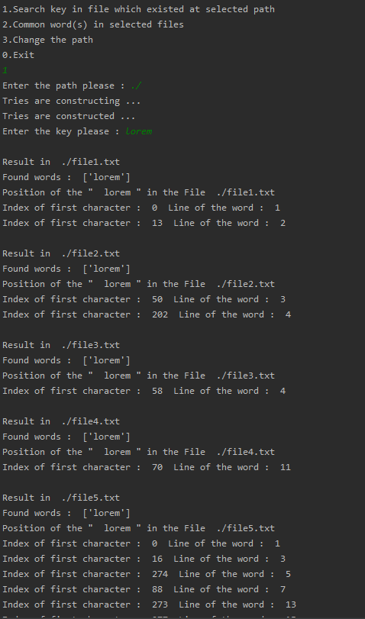

(Sample Output)

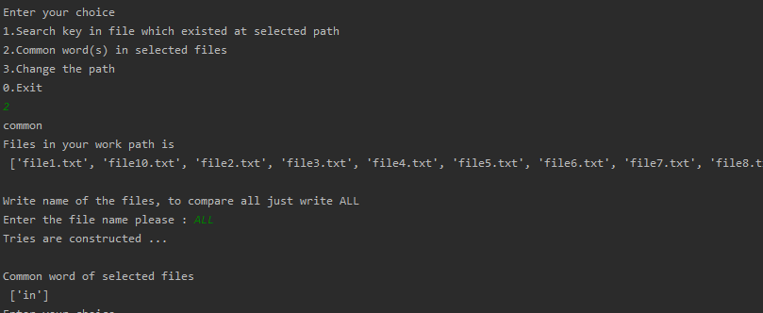

(Sample Output)

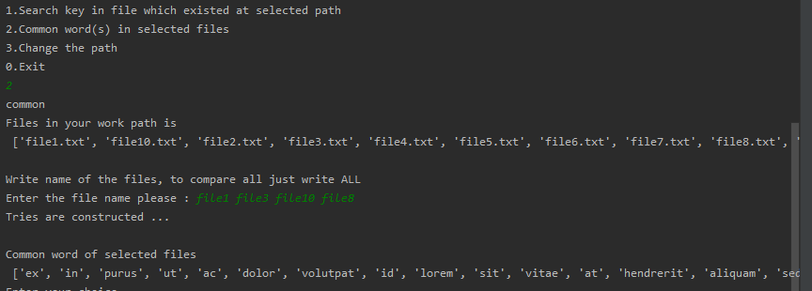

(Sample Output)

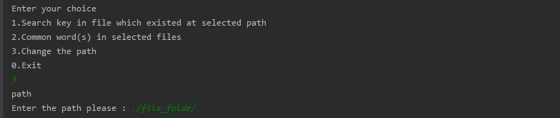

(Sample Output)